Milestone 2 : Tables Creation
- In the Application Navigator, search for System Definition → Tables.
- Click New and create a custom table with the following details:
  - Label: Institution Details
  - Name: u_institution_details
  - Extends for : false
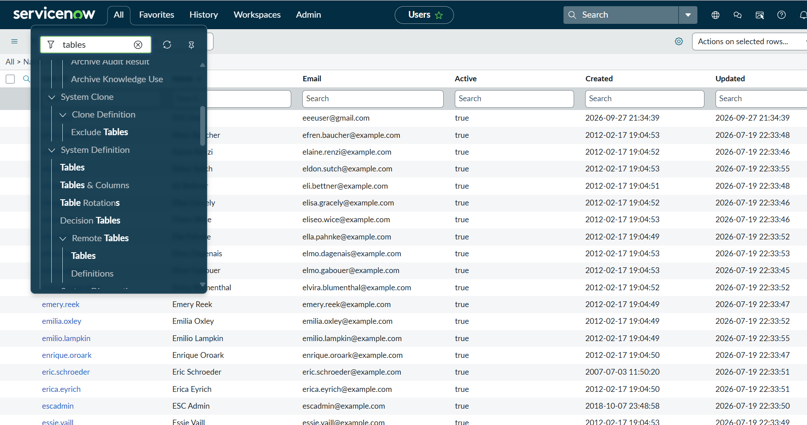
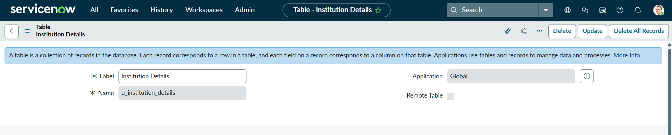
- Click Submit.
- Add the following fields to the u_institution_details table:
  - Student Roll Number– Auto Number
  - Student Name – Reference- User
  - Faculty Name – Reference- User
  - Branch – Choice (ECE, EEE, CSE)
  - Email– String
  - Phone Number– String
  - Description– Multi String
- Save the Table

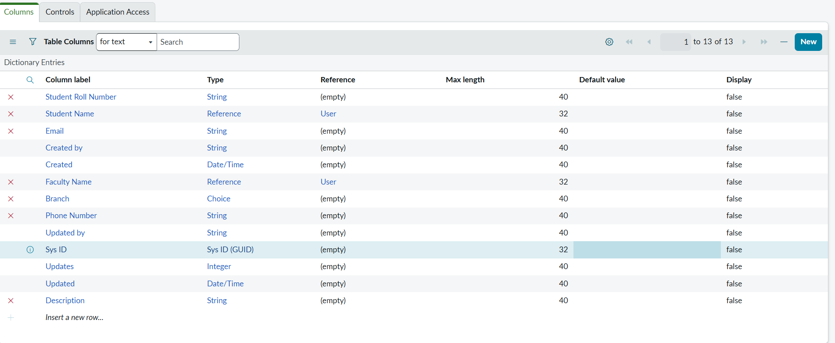
- Create multiple records in the Student Records table with different branch values (ECE, EEE, CSE).


